TRENT VALLEY SURGERY
APPLICATION FOR ONLINE ACCESS TO MEDICAL RECORDS
PLEASE COMPLETE IN BLACK INK AND CAPITAL LETTERS
SURNAME: |  |  |  |  | DATE OF BIRTH:
FIRST NAME: |  |  | MIDDLE NAME:
ADDRESS:
 |  |  |  |  |  | POSTCODE:
LANDLINE: |  | MOBILE:
WORK: |  | EMAIL ADDRESS:
I WISH TO HAVE ACCESS TO THE FOLLOWING ONLINE SERVICES (PLEASE TICK ALL THAT APPLY):
1. | Booking Appointments
2. | Requesting Repeat Medications
3. | Accessing my Medical Record
I WISH TO HAVE ACCESS TO MY MEDICAL RECORD ONLINE AND UNDERSTAND AND AGREE WITH EACH STATEMENT (TICK):
1. | I have read and understood the information leaflet provided by the practice
2. | I will be responsible for the security of the information that I see or download
3. | If I choose to share my information with anyone else, this is at my own risk
4. | I will contact the Practice as soon as possible if I suspect that my account has been accessed by someone without my agreement
5. | If I see information in my record that is not about me or is inaccurate, I will contact the Practice as soon as possible
Signature: |  |  | Date:

FOR PRACTICE USE ONLY:
Patient identity verified by (initials): | Date: |  | Method:  Photo ID  Proof of residence
Authorised by (initials) | Date:
Level of access to record enabled: |  |  | Date online account created:
Booking appointments
Repeat Medication requests |  |  | Date password / username sent:
Summary Record Access
Detailed Coded Record Access

Online access to records GP requirements

GMS regulations 2015-2016 state that practices must promote and offer to patients the facility to view their DETAILED CODED RECORD online by March 2016 (not their full medical record). The level of access will depend on decisions made at the practice.
- A contractor must promote and offer to its registered patients, in circumstances where the GP records of its registered patients are held on the contractor’s computerised clinical systems, the facility of any such patient to access online all information from the patient’s GP record which is held in coded form unless:

  - In the reasonable opinion of the contractor, access to such information would not be in the patient’s best interests because it is likely to cause serious harm to:

  - The patient’s physical or mental health, or

  - The physical or mental health of any other person.

- The information includes a reference to any third party who has not consented to its disclosure, or:

- The information in the GP medical record contains a free text entry and it is not possible under the contractor’s computerised clinical systems to separate that free text entry from other information in the record which is held in coded data form.

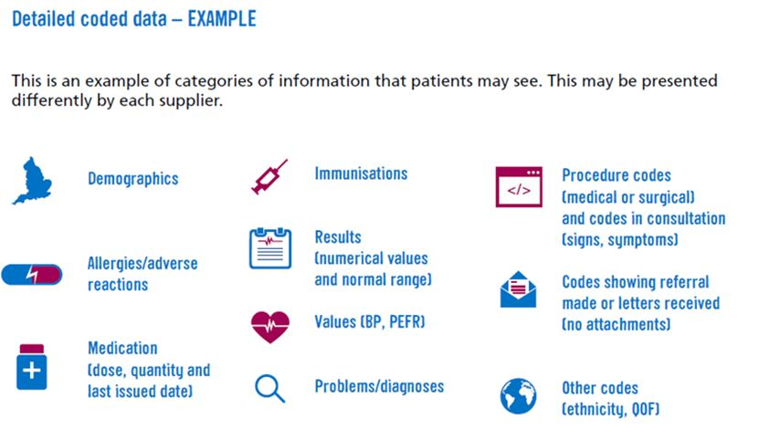

Contractors are NOT REQUIRED to display free text, letters and attachments or administrative items in the medical record.

The patient has a right to submit a Subject Access Request under the Data Protection Act 1998. This differs from accessing online services in that to obtain a copy of their medical records; the patient must put this request in writing to the practice. The practice can charge a fee for providing the information in a printed form. Patients accessing their records online are able to copy and paste or print the information from the screen and there is no fee for this.

